Market Analysis in Banking Domain

Domain: Banking (Market Analysis)

**Background and Objective:**

Your client, a Portuguese banking institution, ran a marketing campaign to convince potential customers to invest in a bank term deposit scheme.   
The marketing campaigns were based on phone calls. Often, the same customer was contacted more than once through phone, in order to assess if they would want to subscribe to the bank term deposit or not. You have to perform the marketing analysis of the data generated by this campaign.

**Source Code:**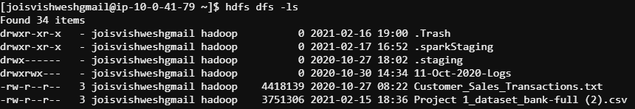

* + Load data and create a Spark data frame

import org.apache.spark.sql.SQLContext

val sqlC=new SQLContext(sc)

val df = sqlC.read.format("com.databricks.spark.csv").option("header","true").option("inferSchema","true").load("/user/joisvishweshgmail/Project 1_dataset_bank-full (2).csv")

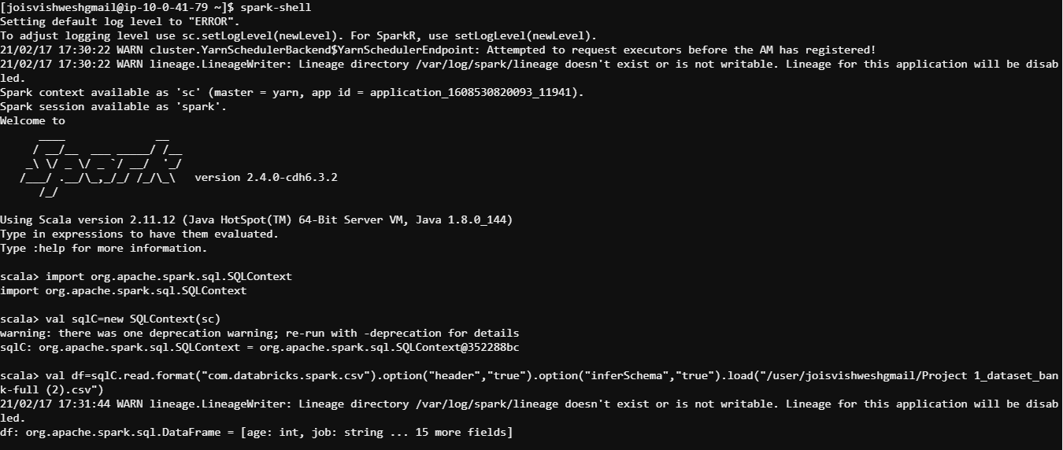

df.printSchema

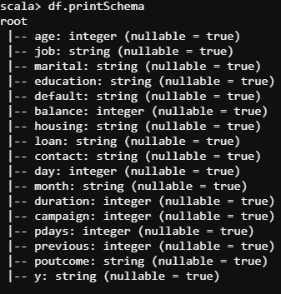

df.show

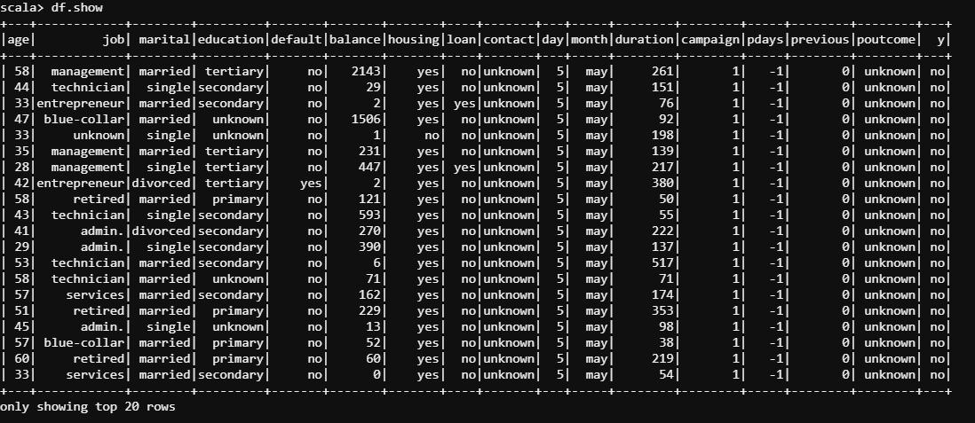

df.registerTempTable("Marketing_Analysis_Table")

sqlC.sql("select * from Marketing_Analysis_Table").show()

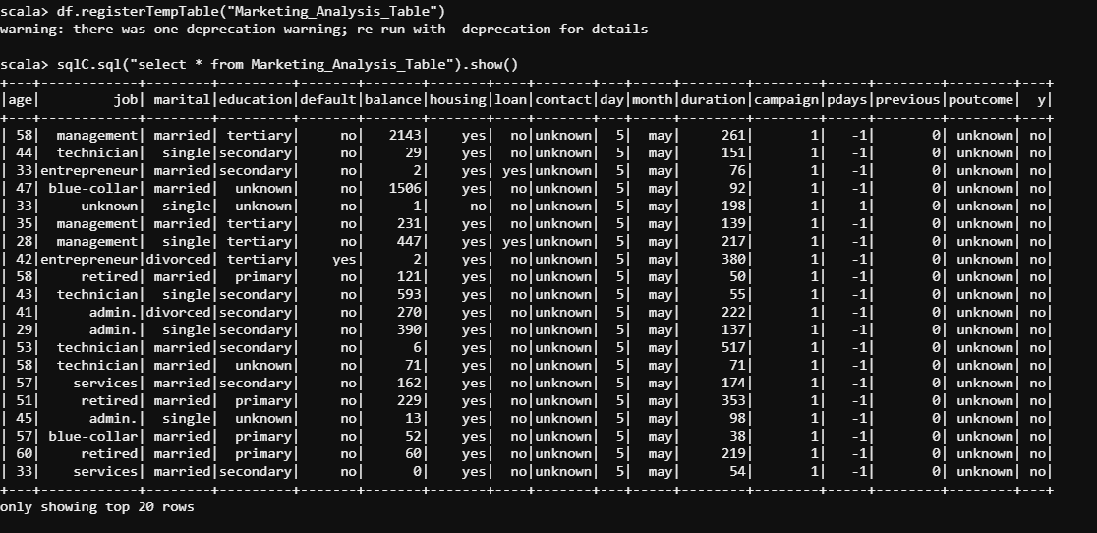

* Give marketing success rate (No. of people subscribed / total no. of entries)

val total=df.count()

val success=df.filter("y='yes'").count()

val success_rate=success*100/total.toFloat

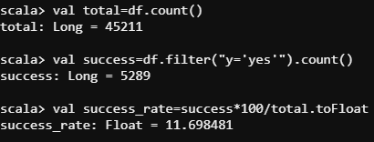

* Give marketing failure rate

val failure=df.filter("y='no'").count()

val failure_rate=failure*100/total.toFloat

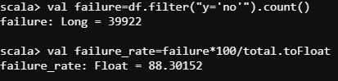

val success_qry=sqlC.sql("select count(1),y from Marketing_Analysis_Table group by y").show

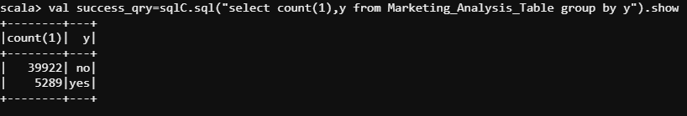

* Give the maximum, mean, and minimum age of the average targeted customer

val max_min_mean_qry=sqlC.sql("select max(age),min(age),avg(age) from Marketing_Analysis_Table").show

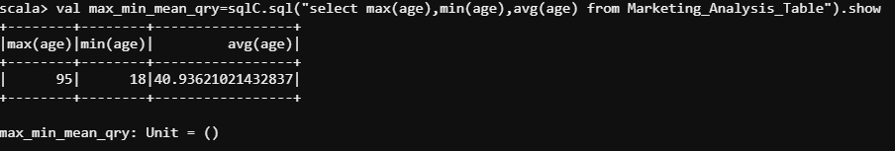

* Check the quality of customers by checking average balance, median balance of customers

val quality=sqlC.sql("select avg(balance),percentile_approx(balance,0.5) from Marketing_Analysis_Table").show()



* Check if age matters in marketing subscription for deposit

val age=sqlC.sql("select y,avg(age) from Marketing_Analysis_Table group by y").show()

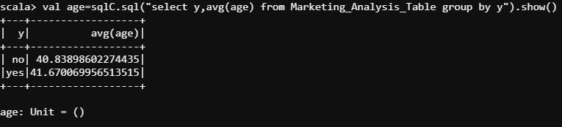

* Check if marital status mattered for a subscription to deposit

val marital=sqlC.sql("select marital,y,count(marital) from Marketing_Analysis_Table group by marital,y order by y").show()

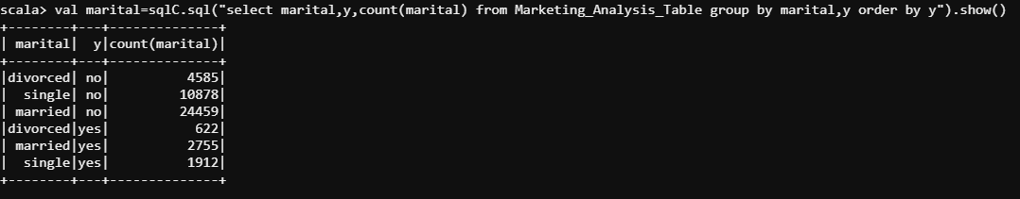

* Check if age and marital status together mattered for a subscription to deposit scheme

val age_marital=sqlC.sql("select marital,y,count(marital),avg(age) from Marketing_Analysis_Table group by marital,y order by y").show()

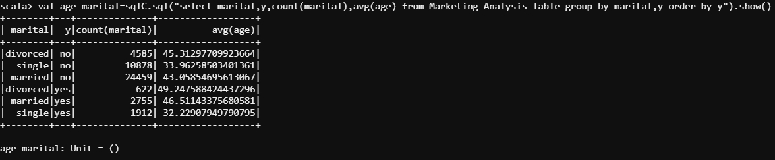

* Do feature engineering for the bank and find the right age effect on the campaign.

val age_group=sqlC.sql("select 'Output','Age','Count' from Marketing_Analysis_Table where 1=0 union select y,'Teen',Count(y) from Marketing_Analysis_Table where y='yes' and age<20 group by y union select y,'Young',Count(y) from Marketing_Analysis_Table where y='yes' and age>=20 and age<30 group by y union select y,'Middle Aged',Count(y) from Marketing_Analysis_Table where y='yes' and age>=30 and age<45 group by y union select y,'Senior',Count(y) from Marketing_Analysis_Table where y='yes' and age>=45 and age<60 group by y union select y,'Old',Count(y) from Marketing_Analysis_Table where y='yes' and age<=60 group by y").show()

